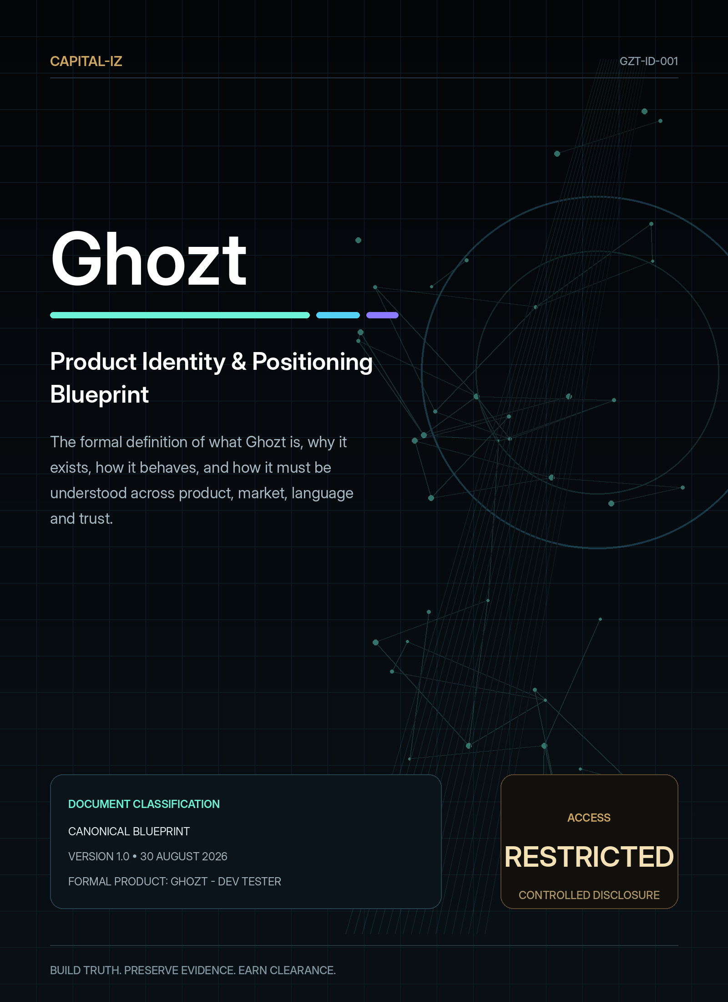

DOCUMENT CONTROL

Ghozt Product Identity & Positioning Blueprint
Defines the permanent product meaning, naming hierarchy, market category, personality, language, trust boundaries and brand-governance rules for Ghozt.
Document code | GZT-ID-001
Product | Ghozt - Dev Tester
Visible brand | Ghozt
Portfolio identity | Capital-Iz Ghozt
Version | 1.0
Issue date | 30 August 2026
Status | Canonical design and technical blueprint
Scope | Product identity, positioning, product promise, users, vocabulary, trust posture and portfolio relationship.
Authority | Capital-Iz product and engineering governance
Source inheritance | Capital-Iz Dev Tester Platform Blueprint; Universal Blueprint Development Doctrine; AI Architecture Blueprint; Universal Design System; CommandDeck implementation reference

CONTROLLED INTERPRETATION
This blueprint defines intended product behaviour and design authority. It does not authorise unbounded access to third-party systems. Ghozt must operate only against targets, environments and actions for which the operator has explicit permission.

01 • THE PRODUCT

Executive product definition
Ghozt is an autonomous software-forensics, quality-certification and development-acceleration platform. It is designed to discover what a system is supposed to do, examine what it actually does, traverse visible and hidden execution paths, reproduce failures, reconstruct their causal sequence, preserve proof, recommend bounded repairs, verify the result and decide whether a build has earned release clearance.
CANONICAL ONE-SENTENCE DEFINITION
Ghozt is an authorised intruder that speed-runs software from intended behaviour to evidence-backed release readiness.

The defining difference is not that Ghozt can execute tests. Many tools execute tests. Ghozt treats the entire application, algorithm or connected system as a forensic scene and every quality claim as a proposition that must be proven against real state.
- It explores, rather than merely follows. Ghozt can begin with manifests, specifications, source code, routes and observed interfaces, then discover additional states and paths that were not manually scripted.
- It reconstructs, rather than merely reports. A failure is represented as a time-ordered chain of actions, inputs, state transitions, responses, environment conditions and dependent events.
- It preserves evidence, rather than merely emits output. Logs, traces, screenshots, recordings, payloads, hashes, build identity and verification results are bound to the finding.
- It certifies, rather than merely scores. A release decision is based on declared gates, verified evidence, known exceptions and residual risk.
- It assists repair, without claiming unauthorised agency. AI may explain, draft and recommend; sensitive code or system changes remain bounded by permissions and review policy.
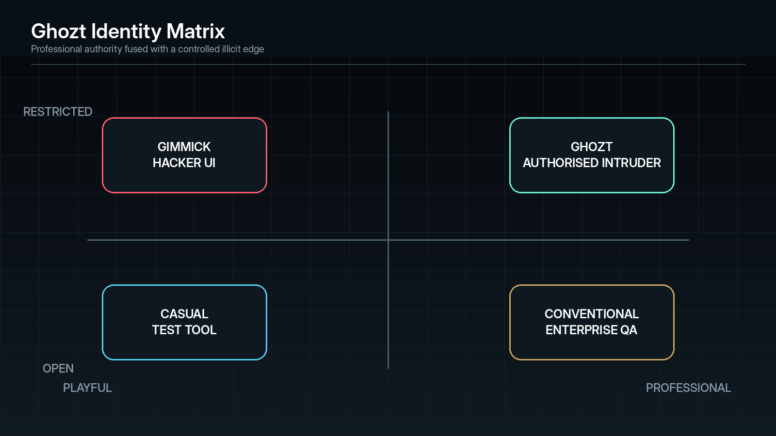
Identity boundary: Ghozt occupies the professional/restricted quadrant—not novelty hacker theatre and not generic enterprise QA.
02 • BRAND AUTHORITY

Naming and labelling lock
The product has one spelling and three governed presentation contexts. The letter substitution in “Ghozt” is intentional and must remain consistent across code, installers, documents, marketing, reports and user interfaces.
Context | Exact form | Where it appears | Rule
Visible application brand | Ghozt | Window title, launcher, navigation shell, splash screen, icon label, notifications, module headers and daily user-facing copy. | This is the normal product label. Do not append a descriptor in routine UI.
Formal product name | Ghozt - Dev Tester | Installer metadata, About page, contracts, product registry, export metadata, procurement and formal documentation. | Use the exact hyphenated form when a descriptor is required.
Capital-Iz portfolio identity | Capital-Iz Ghozt | Portfolio maps, company collateral, cross-product integrations, legal or commercial references and report provenance. | Signals ownership and family relationship; it is not the everyday app label.

Prohibited naming drift
- Do not silently correct the product to “Ghost”.
- Do not use “GHOST”, “Ghozt DevTester”, “CapitalIZ Ghost”, “Ghozt QA” or any re-spelling as a substitute for the canonical names.
- Do not let a module name displace the master brand. A module may be “State Map” or “Replay”, but the shell remains Ghozt.
- Do not overprint “Dev Tester” across the interface. The descriptor is formal metadata, not the personality of the product.
- Do not use ghost imagery, paranormal language or humour in a way that reduces technical credibility.

Recommended naming placements
Surface | Displayed identity
Desktop shortcut / Start menu | Ghozt
Application title bar | Ghozt
System tray | Ghozt
Installer product name | Ghozt - Dev Tester
Windows package publisher | Capital-Iz
Report cover | Ghozt — Software Forensics & Quality Certification
Report metadata | Generated by Capital-Iz Ghozt / Ghozt - Dev Tester
Certificate seal | Ghozt Release Clearance
About screen | Ghozt | Formal product: Ghozt - Dev Tester | A Capital-Iz system

03 • WHY GHOZT EXISTS

Origin, problem and opportunity
Ghozt originates from a practical development bottleneck: modern applications become too broad, interconnected and stateful for one developer to repeatedly press every button, invoke every workflow, test every algorithm, observe every expected output, reproduce every failure and then re-check the entire system after each change.

The underlying problem
- Coverage debt. Features exist without complete, current and provable test coverage.
- Human sweep limits. Manual testing is slow, inconsistent and poorly suited to combinatorial state spaces.
- Fragmented tooling. UI automation, API tests, performance tools, logs, security scanners, algorithm notebooks and release checks often live in separate systems.
- Weak causality. A conventional failure message may identify the final error without explaining the sequence that made it inevitable.
- Low reproducibility. Intermittent faults disappear when a developer tries to inspect them, leaving untrusted fixes and recurring regressions.
- Evidence loss. Screenshots, terminal output, payloads, video, traces and developer notes are not always bound into a single defensible record.
- Fix-loop friction. AI can write code quickly, but the developer still needs a trustworthy system to prove whether the generated change solved the correct problem without breaking something else.
- Release ambiguity. Teams can say “it works” without a consistent gate that distinguishes tested, assumed, waived and unverified behaviour.

The opportunity
The opportunity is to create a super-tester that joins discovery, execution, observability, forensics, repair intelligence, regression protection and certification into one governed operating environment. The product therefore competes less as a single testing utility and more as a quality command system that can coordinate specialised tools while maintaining one record of truth.
04 • STRATEGIC IDENTITY

Mission, vision and product promise
Element | Canonical statement
Mission | To make complete, evidence-backed software examination practical for developers and teams that cannot manually revisit every path after every change.
Vision | Every software build can explain what was tested, what happened, why it happened, what remains uncertain and whether it is safe to release.
Product promise | Ghozt will not merely tell an operator that something failed. It will show the target, build, state, sequence, evidence, reproducibility, causal hypotheses, repair strategy and verification status behind that conclusion.
Operating belief | Testing verifies real state, not claimed completion.
Authority belief | AI is supervised intelligence, not unmanaged agency.
Evidence belief | Completion requires proof against actual state; absence of evidence remains visible as an unverified condition.

Working brand line
NOT YET A LOCKED SLOGAN
Find what the system hides.

This line captures hidden-state discovery without promising unauthorised intrusion. It should remain a working line until formally approved alongside logo, icon and market testing.

Alternative approved-direction lines
- Break it here before it breaks out there.
- Every state. Every path. Every failure.
- Test beyond the visible build.
- Build truth. Preserve evidence. Earn clearance.
- Test like an intruder. Report like an examiner.
05 • CHARACTER

The authorised-intruder archetype
Ghozt should feel as though it possesses access to a restricted technical chamber and can move through a system in ways ordinary operators cannot. The edge is intentional, but it is controlled. Ghozt is not an outlaw; it is a highly privileged examiner whose permission, evidence and actions are always visible.
Identity trait | Meaning in the product | What it must never become
Futuristic | A coherent system for state mapping, autonomous traversal, live evidence and multi-agent reasoning. | Decorative science-fiction surfaces with no operational meaning.
Restricted | Access scope, destructive permissions, environment, target and clearance are explicit at all times. | Aesthetic claims of secrecy that hide real authority or encourage unauthorised access.
Forensic | Every material conclusion can be traced to state, sequence, source and evidence. | A conventional test runner with a cosmetic “forensics” label.
Professional | Reports, terminology, controls and outputs can withstand engineering, audit and executive scrutiny. | Juvenile hacker clichés, fake terminals, skulls, hooded figures or excessive glitch effects.
Slightly illicit | The system feels capable of reaching forbidden-looking states, breaking assumptions and interrogating hidden behaviour. | Criminal positioning, hostile exploitation or ambiguous permission.
Calm | Ghozt communicates precise status and severity without drama. | Constant alarms, flashing red surfaces or sensational language.
Relentless | The explorer continues until scope, budget, policy or evidence stops it—not until the happy path passes. | Blind brute force that ignores cost, risk, side effects or authorisation.

THE IDENTITY TEST
A screen is on-brand when it makes the operator feel that a disciplined, highly privileged forensic system is examining the target. It is off-brand when it looks like a game, a generic admin dashboard or a copied CommandDeck surface.

06 • MARKET CLARITY

Category definition: what Ghozt is and is not
Ghozt is | Ghozt is not
An autonomous test-exploration and software-forensics platform. | Only a UI click recorder.
A governed orchestrator for multiple test modalities and adapters. | A replacement for every specialised underlying tool.
A state and evidence system that binds expected and actual behaviour. | A dashboard that merely aggregates disconnected pass/fail totals.
A counterfactual fault-reconstruction environment. | A log viewer that guesses root causes without reproducible evidence.
An algorithm and model validation laboratory. | Only a website testing product.
A repair-intelligence and regression-verification loop. | An AI coding agent with unrestricted write authority.
A release-clearance authority operating against declared policy. | A universal guarantee that software is defect-free.
A private product that can later support enterprise and public distribution. | A public cloud dependency by definition.

Relationship to familiar tool categories
Category | Typical contribution | Ghozt relationship
Unit and integration frameworks | Deterministic code-level assertions. | Ghozt imports, executes, correlates and includes the results in a larger evidence graph.
UI automation | Scripted interaction and visual checks. | Ghozt can generate, prioritise, execute and forensically replay UI paths, including unscripted state discovery.
API testing | Endpoint invocation, contracts and response assertions. | Ghozt maps endpoint relationships to workflows, state changes and downstream evidence.
Performance auditing | Loading, latency, resource and rendering measurements. | Ghozt applies PageSpeed-style scoring and recommendations across broader app, service, algorithm and workflow dimensions.
Observability / APM | Logs, traces, metrics and runtime behaviour. | Ghozt consumes observability evidence and binds it to a controlled test sequence and expected result.
Security testing | Attack-surface and vulnerability validation. | Ghozt can orchestrate authorised security modules, while maintaining strict policy and scope boundaries.
AI coding | Code generation, editing and explanation. | Ghozt supplies a verified fault brief, constrains the requested change and proves the result after implementation.
Release management | Build promotion and deployment controls. | Ghozt produces evidence-backed clearance or denial decisions for use by release systems.

07 • FROM IDEA TO PUBLISH

The Ghozt value lifecycle
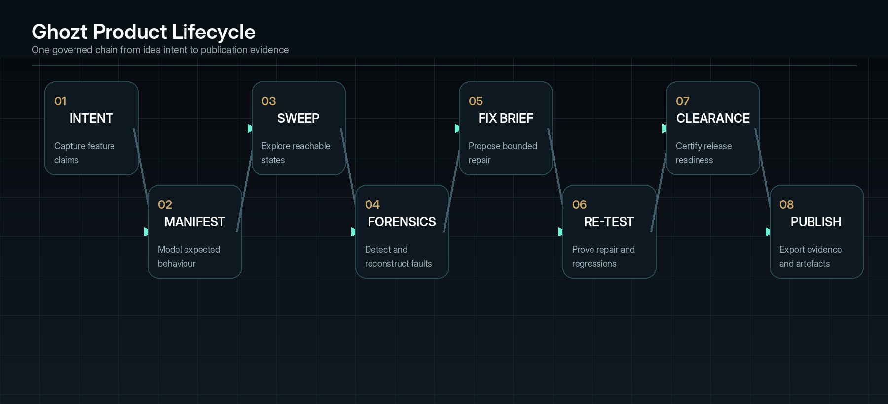
Ghozt’s product identity is expressed through one evidence-preserving lifecycle, not isolated testing features.
01 | Intent capture — Receive product idea, specification, issue, acceptance criteria, design reference, API contract, source repository or running build.
02 | Behaviour manifest — Translate intended behaviour into entities, roles, workflows, inputs, outputs, permissions, risk, expected state, failure state and verification method.
03 | Discovery and sweep — Map the target, identify reachable surfaces and execute approved exploration across UI, APIs, services, data, algorithms and environments.
04 | Forensic finding — When a deviation occurs, preserve the exact event sequence, actual/expected difference, build context and evidence.
05 | Fix intelligence — Produce ranked cause hypotheses, reproduction steps, bounded repair strategies and tests that must prove the repair.
06 | Repair execution — Allow a human or permitted coding agent to implement the change against a controlled branch or environment.
07 | Re-test and regression — Replay the minimal reproducer, test adjacent states and maintain a regression guard against recurrence.
08 | Clearance and publication — Generate technical evidence, human-readable reports, machine-readable results and a release decision under declared policy.
08 • WHO GHOZT SERVES

Primary users and jobs to be done
User | Primary need | Ghozt outcome
AI-assisted solo developer | Move quickly without manually repeating every workflow after generated changes. | An autonomous examiner that discovers coverage gaps, produces precise fix briefs and proves repairs.
Product engineer / full-stack developer | Understand cross-layer failures spanning UI, API, services and data. | One causal timeline connecting actions, calls, state deltas and evidence.
QA engineer | Scale coverage, reduce flaky-test investigation and maintain regression confidence. | Exploration, reproducibility scoring, path minimisation, evidence and reusable guards.
Technical lead / architect | Know whether system behaviour matches architecture and declared contracts. | Coverage against manifests, dependency maps, policy violations and clearance status.
Algorithm / ML engineer | Validate algorithms, models, data assumptions and non-deterministic outputs. | Controlled datasets, invariants, metamorphic checks, drift tests and explainable failure comparisons.
Security / reliability engineer | Examine high-risk paths and operational failure states under authorisation. | Scoped adversarial runs, resilient evidence capture and risk-ranked findings.
Release manager | Decide whether a build should move forward. | A policy-bound clearance dossier showing passes, failures, waivers and unverified scope.
Auditor / client reviewer | Understand what was tested without reading raw logs first. | A professional narrative report linked back to raw evidence and reproducible cases.

Core jobs-to-be-done
- When a feature is created or changed, prove that its expected behaviour exists across relevant states.
- When a failure occurs, reconstruct the sequence and determine whether it can be reproduced.
- When a defect appears intermittent, isolate the conditions that make it appear or disappear.
- When AI proposes a change, constrain the repair and verify that it addresses the proven cause.
- When a release decision is required, distinguish verified, failed, waived, blocked and untested scope.
- When an executive or client needs assurance, translate technical evidence into a professional, readable dossier without losing the raw record.
09 • NON-NEGOTIABLE CAPABILITIES

Product pillars
Pillar | Definition
01 COMPLETE STATE INTENT | Every in-scope feature has an expected result, test path, evidence requirement and regression guard.
02 AUTONOMOUS EXPLORATION | The system discovers and prioritises paths instead of relying exclusively on pre-written scripts.
03 COUNTERFACTUAL FORENSICS | The platform tests alternative sequences and conditions to distinguish correlation from supported cause.
04 REPRODUCIBLE EVIDENCE | Findings bind exact target, build, environment, sequence, state, artefacts and verification.
05 BOUNDED REPAIR INTELLIGENCE | AI produces fix briefs and may execute only through explicit permissions and review gates.
06 REGRESSION MEMORY | A confirmed fault becomes a durable guard that is replayed against future builds.
07 CLEARANCE GOVERNANCE | Release claims are policy decisions backed by evidence—not generic pass percentages.
08 HUMAN + MACHINE REPORTING | Every run can produce raw logs, machine-readable output and an executive-grade narrative report.

10 • HOW GHOZT SPEAKS

Product voice and operational language
Ghozt’s voice is concise, calm, technical and evidential. It reports observed facts, current confidence and required next action. It never pretends that a guess is proof or that an action occurred when only a draft was produced.
Rule | Preferred | Avoid
State facts before interpretation | “HTTP 500 observed after token refresh in 4 of 4 controlled runs.” | “The authentication system is definitely broken.”
Expose confidence | “Cause candidate: null identity claim; confidence 0.93; supported by trace and payload comparison.” | “AI found the root cause.”
Use direct actions | Start Sweep; Reproduce; Compare Runs; Open Evidence; Re-test; Issue Clearance. | Haunt; Possess; Exorcise; Summon.
Separate severity from drama | “Critical: uncontrolled data loss reproduced.” | “Catastrophic breach detected!!!”
Make uncertainty visible | “Unverified: destructive path not authorised in this environment.” | Silently omit the path from coverage.
Keep forensic terms meaningful | Finding; event; state; sequence; evidence; reproducer; hypothesis; verification. | Random cyber terminology used only for atmosphere.

Canonical status vocabulary
State | Definition | Semantic treatment
Unseen | In scope but not yet explored. | Neutral / dim
Queued | Approved and waiting for execution. | Informational
Watching | Currently being observed or traversed. | Spectral mint / cyan
Verified | Expected result proven with evidence. | Green
Deviation | Actual state differs from expected state; confirmation pending. | Amber
Fault | Confirmed failure under defined conditions. | Red
Phantom | Intermittent or not yet reliably reproducible. | Ultraviolet
Reproduced | Failure recreated under recorded conditions. | Red + evidence seal
Contained | Cause isolated or harmful propagation stopped. | Amber / green
Review Required | Evidence, authority or AI confidence is insufficient. | Amber
Cleared | Release requirement satisfied. | Capital-Iz gold
Clearance Denied | One or more mandatory release gates failed. | Critical red

11 • AUTHORITY BOUNDARIES

Trust, permission and responsible-operation identity
The product may feel like restricted-access technology, but its trust model must be more explicit than ordinary testing tools. Ghozt’s credibility depends on never confusing technical capability with permission.
- Target authority. Every target is registered with ownership, environment, permitted scope and authorising actor.
- Action authority. Read-only, state-changing, destructive, financial, privacy-sensitive and production actions use separate permission classes.
- Environment separation. Local, simulation, test, staging and production targets are visually distinct and subject to different policies.
- Human approval. High-risk execution requires human approval, even when an agent recommends it.
- Evidence minimisation. Capture only what is necessary; redact secrets and personal data; apply retention rules and access control.
- Reversibility. State-changing tests should use snapshots, fixtures, transactions, reset hooks or explicit rollback plans where possible.
- No hidden agency. Every agent role, tool call, approval, action and result is recorded.
- Honest limits. Ghozt must report uncovered scope, unavailable evidence, low confidence and blocked actions rather than manufacture certainty.
RESTRICTED DOES NOT MEAN UNAUTHORISED
The product’s illicit edge is a design and capability metaphor. It must never imply permission to test systems, accounts, networks or data that the operator is not authorised to examine.

12 • PORTFOLIO IDENTITY

Capital-Iz family relationship
Ghozt must be visibly related to Capital-Iz systems through design discipline, governance patterns and semantic architecture—not through copied screens. CommandDeck is the strongest existing reference for family feel, but Ghozt requires its own colder, forensic and more restricted expression.
Shared Capital-Iz DNA | Ghozt interpretation
Premium dark operational structure | A colder examination chamber with spectral telemetry and tighter geometry.
Restrained premium accent | Spectral mint and cyan for operation; gold reserved for authority, evidence seals and clearance.
Action-first interface | Sweep, reproduce, compare, inspect, re-test and clear remain dominant actions.
Visible state and risk | Target, build, environment, access, recorder, evidence and clearance stay visible.
Dense but readable layout | High information density with a central state lattice, forensic inspector and raw stream.
Reusable semantic components | Every control consumes semantic tokens and shared states rather than literal styling.
Governed execution | Structure → Validation → Execution → State → Event → Audit applies throughout.
Supervised intelligence | Agents observe, classify, draft, recommend, request approval, execute through services and record evidence.

FAMILY METAPHOR
CommandDeck is the command centre. Ghozt is the restricted examination chamber beneath it.

13 • INTERNAL LANGUAGE

Product and module naming architecture
Product layer | Recommended label | Purpose
Master shell | Ghozt | The entire application and visible brand.
Full autonomous test operation | Sweep | A governed run across selected scope.
Reachable-state representation | State Map / State Lattice | The connected graph of features, routes, states, transitions and evidence.
Fault reconstruction | Replay | Time-ordered reproduction and inspection of the event chain.
Alternative-cause examination | Counterfactual Lab | Controlled variation of sequence, environment, state or input.
Raw evidence store | Evidence Vault | Immutable or tamper-evident artefacts, manifests and chain of custody.
Algorithm validation | Algorithm Lab | Controlled execution, invariants, data comparisons and model tests.
Regression memory | Regressions | Durable guards created from confirmed faults and feature contracts.
Human-readable reporting | Dossier | Professional narrative findings and recommendations.
Release decision | Clearance | Policy-backed certification, denial or conditional waiver.
Autonomous worker | Ghozt Agent | A bounded role with declared tools, permissions and evidence output.

These labels are recommended architecture vocabulary. They may be refined during implementation, but no module should introduce a competing master brand.
14 • HOW THE PRODUCT MAY BE OFFERED

Commercial positioning and packaging direction
The initial product may remain private while the architecture is stabilised. The identity must nevertheless support a future path from personal development system to team, enterprise and public distribution without renaming the product.
Potential edition | Positioning | Identity rule
Ghozt Local | Private workstation deployment for a developer or small team; local execution and evidence. | Still branded simply Ghozt in-app.
Ghozt Team | Shared projects, roles, run queues, evidence review and release gates. | Team features do not alter the master identity.
Ghozt Enterprise | Private infrastructure, policy, SSO, device labs, audit retention, approvals and fleet execution. | Capital-Iz ownership and governance become more visible in formal surfaces.
Ghozt Cloud | Managed orchestration and distributed execution, should it later be offered. | Cloud is a deployment model, not the core product identity.
Ghozt SDK / Agent | Embeddable adapters, runners and CI integrations. | Sub-products remain subordinate to Ghozt.

NO PREMATURE EDITION LOCK
These are expansion-compatible packaging directions, not approved commercial SKUs. Pricing, public availability, deployment and trademark clearance require separate decisions.

15 • PROVING PRODUCT VALUE

Identity-aligned success measures
Measure | What it proves | Example form
Verified feature coverage | How much declared behaviour has evidence, not merely scripts. | Verified requirements ÷ in-scope requirements.
Reachable-state exploration | How much discovered state space has been exercised under policy. | Explored weighted states ÷ discovered weighted states.
Fault reproducibility | Whether findings can be reliably recreated. | Successful reproductions ÷ controlled attempts.
Causal confidence | Strength of evidence for the ranked cause. | Evidence-weighted hypothesis score with uncertainty.
Mean time to verified repair | Time from first finding to passing reproducer and regression suite. | Median elapsed time by severity.
Regression prevention | Whether previously confirmed faults remain blocked. | Regression guards passing across subsequent builds.
Evidence completeness | Whether required artefacts and context exist for each conclusion. | Complete evidence bundles ÷ reportable findings.
Clearance integrity | Whether release decisions match declared gates and known residual risk. | Policy evaluation with explicit waivers and unverified scope.
Developer effort displaced | Manual examination time avoided without reducing confidence. | Estimated manual steps/time replaced by verified autonomous runs.

16 • HOW THE BRAND STAYS TRUE

Identity governance and acceptance criteria

A Ghozt feature is identity-compliant only when
- It contributes to discovery, evidence, causality, repair, regression or clearance rather than merely adding visual novelty.
- Its state, target, authority and outcome can be understood by an operator.
- It distinguishes observed fact, system inference, AI recommendation and human decision.
- It can expose the raw evidence behind summaries and scores.
- It does not hide missing coverage or insufficient confidence.
- It uses Ghozt’s vocabulary consistently and preserves the naming lock.
- It can fit the Capital-Iz control, execution and intelligence architecture.
- It remains useful without cyberpunk decoration or theme effects.
- It handles error, permission denial and partial execution as designed states.
- It can be audited after the fact.

Identity rejection rules
- Reject any design that relies on “hacker” clichés instead of forensic capability.
- Reject any marketing claim that implies defect-free certification or universal causality.
- Reject any autonomous action that is not permissioned, logged and attributable.
- Reject any report that cannot link back to build identity, sequence and evidence.
- Reject any theme or language change that reverses the meaning of risk states.
- Reject hidden logic, duplicated unmanaged structures and claims of completion without verification.

Source inheritance and Ghozt-specific expansion
Source authority | Inherited doctrine | Ghozt-specific expansion
Capital-Iz Dev Tester Platform Blueprint | Control, Execution and Intelligence layers; evidence-backed testing; unit, integration, UI, workflow, security, performance and deployment smoke validation. | Autonomous state exploration, forensic replay, counterfactual causality, algorithm laboratories, evidence dossiers and release clearance.
Universal Blueprint Development Doctrine | Structure → Validation → Execution → State → Event → Audit; rejection of hidden logic and unverifiable execution. | Each Ghozt workflow, agent and test adapter receives explicit contracts, permissions, failure states, verification and audit output.
Capital-Iz AI Architecture Blueprint | Supervised intelligence; bounded roles; approval before high-risk execution; evidence recording. | Specialist test agents, causal-analysis agents, fix-brief agents and report agents governed through policy gates.
Capital-Iz Universal Design System | Clarity over decoration; high contrast; restrained premium accents; action-first, reusable and state-visible UI. | Restricted forensic-tech visual language, state lattice, black-box stream and twelve Ghozt palettes.
CommandDeck implementation reference | Semantic theme tokens, runtime palette switching, dark/light derivation, controlled glass/gradient/glow and responsive operational layout. | A new Ghozt token namespace, twelve product-specific palettes, tighter forensic geometry and evidence-first workspaces rather than copied CommandDeck screens.

17 • GOVERNANCE REGISTER

Locked decisions and open identity decisions
Item | Status | Decision / next authority
Product spelling: Ghozt | LOCKED | Must not be corrected or substituted.
Visible app label: Ghozt | LOCKED | Use throughout the operating UI.
Formal product: Ghozt - Dev Tester | LOCKED | Use in formal metadata and documentation.
Portfolio form: Capital-Iz Ghozt | LOCKED | Use for company ownership and cross-product context.
Core archetype: authorised intruder | LOCKED DIRECTION | Professional, forensic, futuristic and slightly illicit; never criminal or theatrical.
Category: autonomous software forensics and quality certification | RECOMMENDED | Validate during market research without reducing the scope to ordinary QA.
Working brand line: Find what the system hides. | OPEN | Requires formal approval and later trademark/market review.
Logo and icon | OPEN | Must express presence, access and forensic precision without literal ghost illustration.
Commercial editions | OPEN | Define after private product architecture and target customer validation.
Trademark, domains and app-store availability | OPEN | Requires formal clearance before public launch.

Ghozt
END OF CONTROLLED BLUEPRINT
This document forms part of the Capital-Iz Ghozt canonical product specification. Superseding revisions must preserve the naming lock, evidence doctrine, authority boundaries and traceability requirements defined herein.
CAPITAL-IZ • BUILD TRUTH. PRESERVE EVIDENCE. EARN CLEARANCE.

